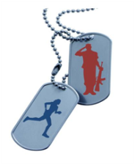
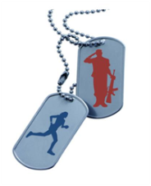
ROCKY’S RUN FOR FREEDOM 5K

Charitable Donation Form

Thank you for your interest in the 14th Annual Rocky’s Run for Freedom 5K Run/Walk!
Please complete the form below to submit your donation for sponsorship.
All forms must be submitted by May 8, 2026, to be eligible for name/logo on shirt.
Please make checks out to: Rocky’s Run for Freedom
Please mail your completed form and check to:
Rocky’s Run for Freedom 5K
c/o Nicole Zanowick-Smith, Race Director
951 E. Central Ave.
Miamisburg, Ohio 45342

Name of Person/Business:
Address: ____________________________________________________________________
City: _________________________ State: ___________________ Zip: __________________
Name of Contact Person: _______________________________________________________
Phone: ______________________________ E-mail: _________________________________
Sponsor Level/Amount:

Red | White | Blue | Patriot
  $100 - $249
  $250-$499
  $500-$749
  $750+
Name on race shirt | *Logo on race shirt | *Logo on race shirt | *Large Logo on race shirt
Name on sponsor board | Name on sponsor board | Name on sponsor board | Name on sponsor board
Flyers in race bag | Flyers in race bag | Flyers in race bag | Flyers in race bag
 | Certificate | Framed Certificate | Framed Certificate
 |  | Table at run | Table at run
 |  |  | Sponsor mile marker with logo on race course (1 of 3)
*Please e-mail a high-quality copy of your logo to RockysRunforFreedom@gmail.com by May 8, 2026

Please come out and join us on Saturday, May 23, 2026 for the event.
Thank you for your generous support!
Nicole Zanowick-Smith

